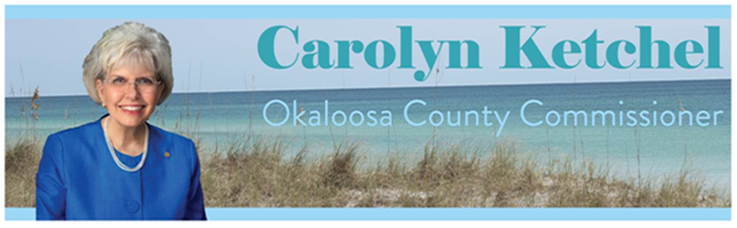

**Brooks Bridge and Santa Rosa Boulevard Improvements**

The FDOT Brooks Bridge Replacement Project Development and Environmental Study have been completed and aesthetics workshops have taken place. The design has been carefully vetted and replacement with a state-of-the-art bridge is underway. The careful design of the bridge and upcoming proposed bike path makes this the right time to improve Santa Rosa Boulevard. Click [here](https://bit.ly/BrooksBridgeReplacement) to see planned improvements to traffic flow, safety standards and aesthetics in a computer- generated animation of the Brooks Bridge replacement.

As the Brooks Bridge Replacement project moves forward there are many unfounded truths regarding buildings that will be demolished. Everything that needed to be removed for the construction of the Brooks Bridge has been removed. Nothing else is scheduled to be moved, removed or demolished, other than the bridges themselves.

The north side of the bridge will be constructed first. When the north side is finished, the south side will begin after which we will finally have our new Brooks Bridge. The new six-lane bridge will be completed by 2027. The bridge will be 10 feet higher than the existing bridge, and will begin on the Fort Walton Beach side immediately east of the Perry Avenue intersection with US 98.

The great news is that it will bypass the existing intersection of Santa Rosa Boulevard with a new landing point just west the convention center. Traffic on Santa Rosa Boulevard will go under the new bridge with access to either a dedicated lane to get to Fort Walton Beach or an access road before the bridge to go to Destin. With additional lane capacity on the bridge, and the removal of the current intersection at Santa Rosa Boulevard, traffic in the area will flow more freely.

This new configuration will minimize traffic delays on Santa Rosa Boulevard, even during times of heavy traffic. After almost two years of reviews by year-round residents, we are pleased with the overwhelming support of the proposed Okaloosa Island improvements for Santa Rosa Boulevard. Through analysis of traffic patterns, input from residents and community partners, and expert advice of county engineers on the improvement concepts, the Board of County Commissioners voted unanimously in support of the changes for Okaloosa Island.

Motor vehicle lanes will range from 5 lanes at the heaviest point of entry, down to 2 lanes headed West, approaching the end of public access at the Eglin Airforce Base access. Make sure you view the attached videos so that you can see how the lane changes make for a better traffic flow with the new intersections at the Brooks Bridge.

Pedestrian-friendly features will be integrated into the design, such as sidewalks and a multi-use path, in addition to aesthetic landscape features. Click [here](https://bit.ly/SantaRosaBlvd) to view renderings of improvement concepts.

By vote of five to zero on Tuesday, April 18, 2023, the Board of County Commission voted unanimously to support a $610,000 expenditure for design and construction development drawings for the redevelopment of Santa Rosa Boulevard. We are one step closer to getting this project under way!

Okaloosa Island will have stormwater and infrastructure improvements, including a multimodal path and bicycle lanes, for enhanced safety of motorists and pedestrians. The county also considered input from Eglin Air Force Base in the concepts by implementing a gradual decrease of lanes at the West end of Santa Rosa Boulevard rather than the abrupt 4-lane stop at the Eglin gate. While the majority of the audience was in favor of the improvements proposed, a few expressed resistances to change.

We continue to work with Florida Power and Light to identify ways to bury the power lines on the Island. We know at some point we will have a hurricane, or significant weather event, and underground lines would reduce the time needed to return power to our citizens.

Design drawings are being developed now. Once detailed topographic, soil, and utility information has been analyzed the many details required to properly design the improvements will be established and a construction schedule can be developed.

Finally, a proposed Bridge to Bridge Bike Path is in final stage of improvement with Eglin AFB. If built from Brooks Bridge to Destin (Marler) Bridge, this 12-foot-wide bike path, on the Gulf side, will save countless lives and injuries.

My Sincere Thanks,



Carolyn N. Ketchel

District 2 County Commissioner

Okaloosa County, Board of County Commissioners

1250 N Eglin Pkwy., Suite 100

Shalimar, FL 32579

850-651-7105

cketchel@myokaloosa.com